TRAVELOGUE

Abstract:

* The number of people who loves travelling increases.
* This causes for us to have a specified application to know the tourist spots in the area.
* Now people uses websites like Google, Yahoo etc to search for the places that are good to visit either as a family or a single.
* The proposed system “Travelogue” is used to view the tourist spot of interest.
* The system uses common techniques for upload and retrieve data.

Proposed System :

* There is no particular website to suggest the tourist spot.
* There are also applications like in Instagram and Facebook through which we can share our thoughts through post.
* The proposed system is similar to that, I which the user has their own page where he/she can share their experience.
* The big advantage is that we can know even the small spots and it is fully to suggest the tourist spots.

Technologies Used:

* + Java
  + Html, CSS
  + JSP
  + MySQL
  + JavaScript
  + Spring MVC, Hibernate

Project Work Flow:

* The proposed project has two modules, Admin and User
* The user registers and login to their page.
* They may upload their review as suggestion to other users.
* The most unvisted and unique user’s suggestion is selected.
* The admin can also view the suggestions.

MYSQL: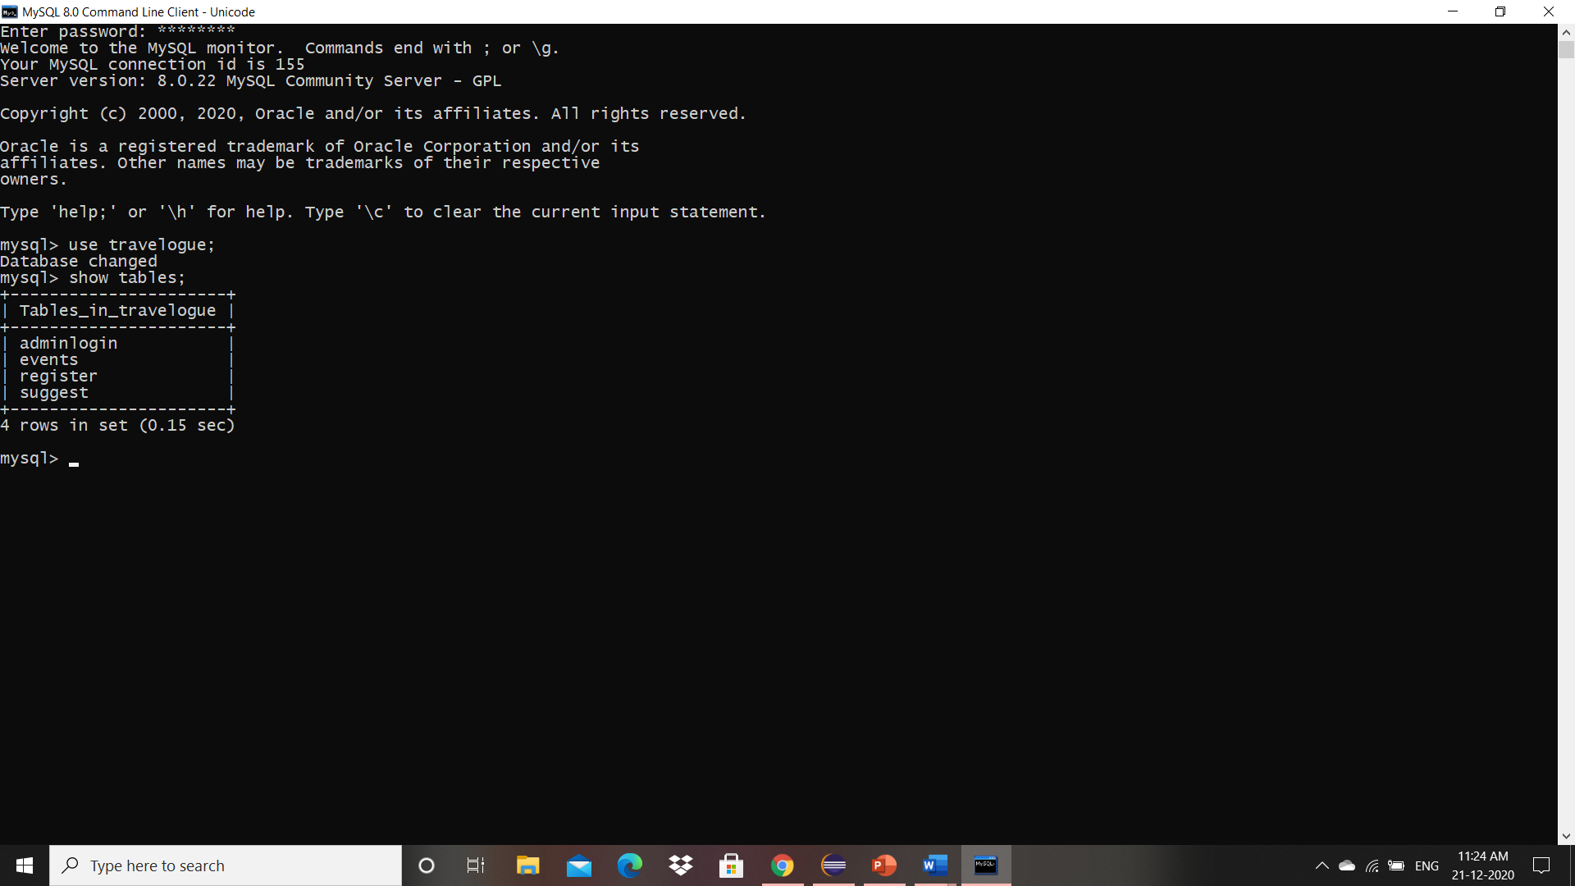

Front Page:

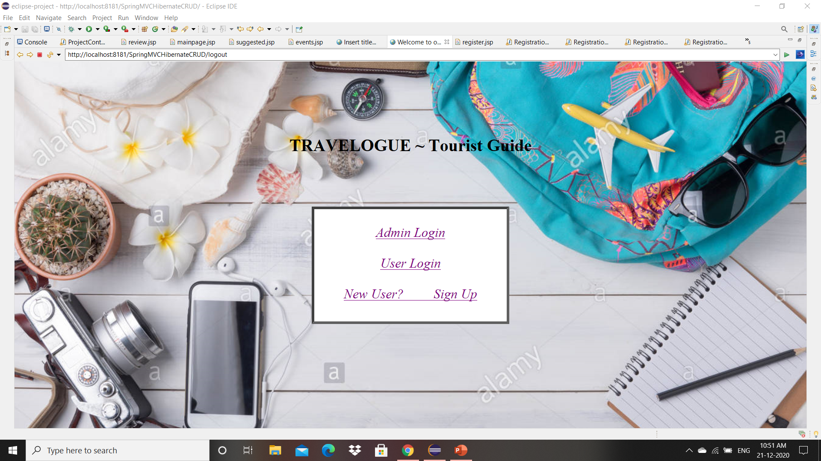

Events suggested by admin

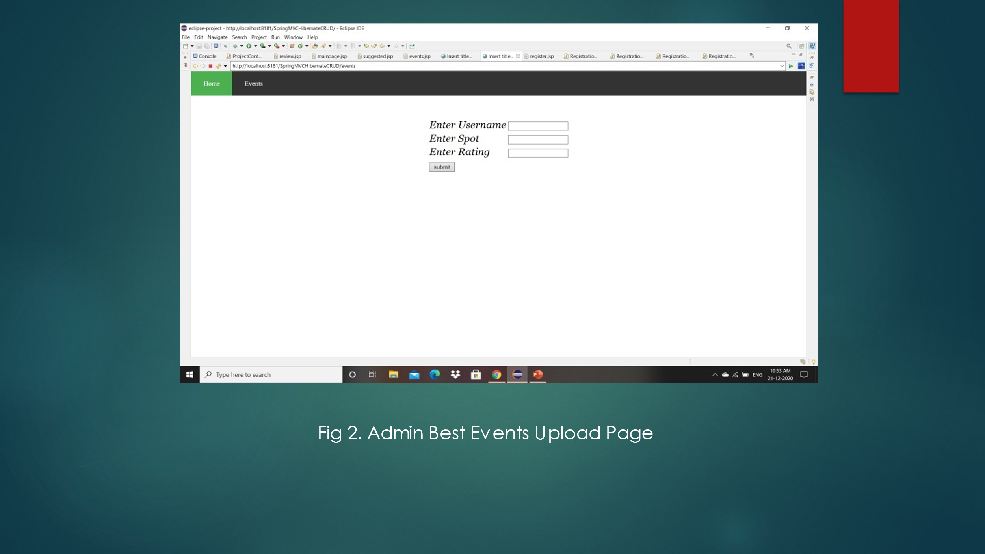

Registration Page: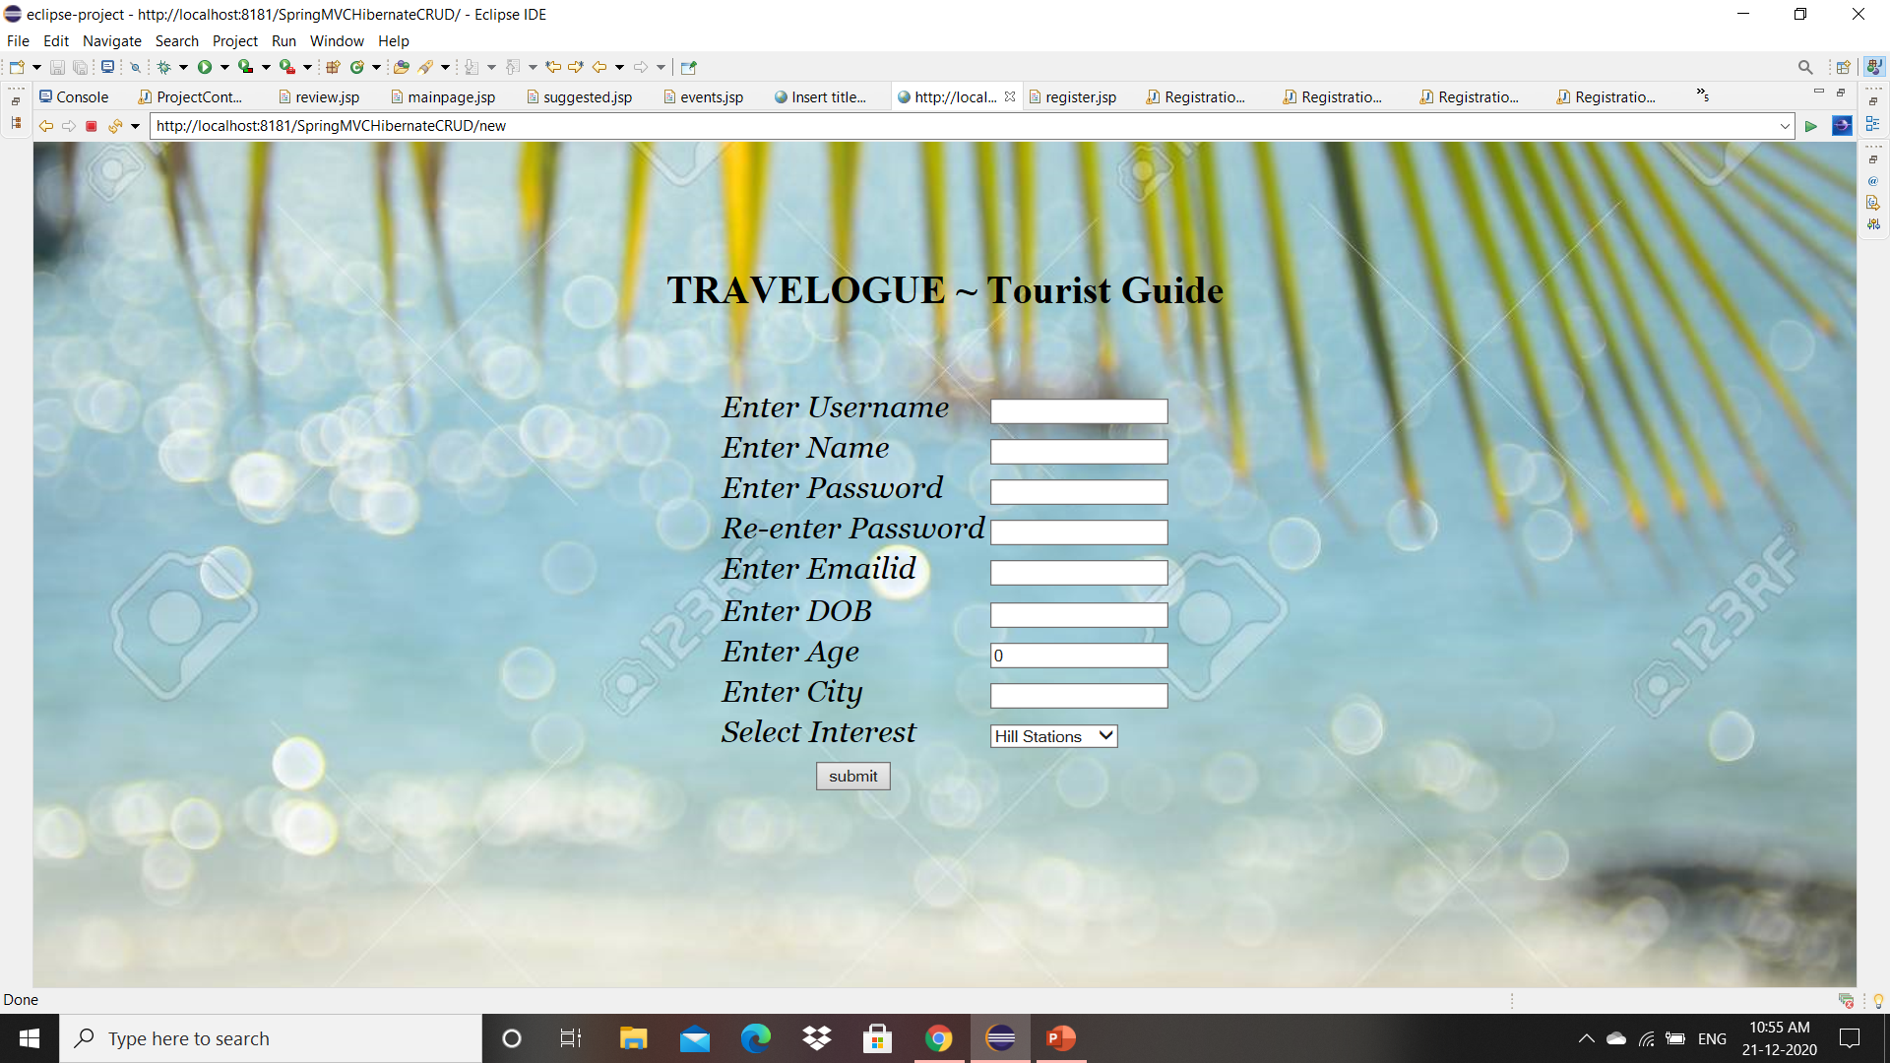User Suggestion Upload: 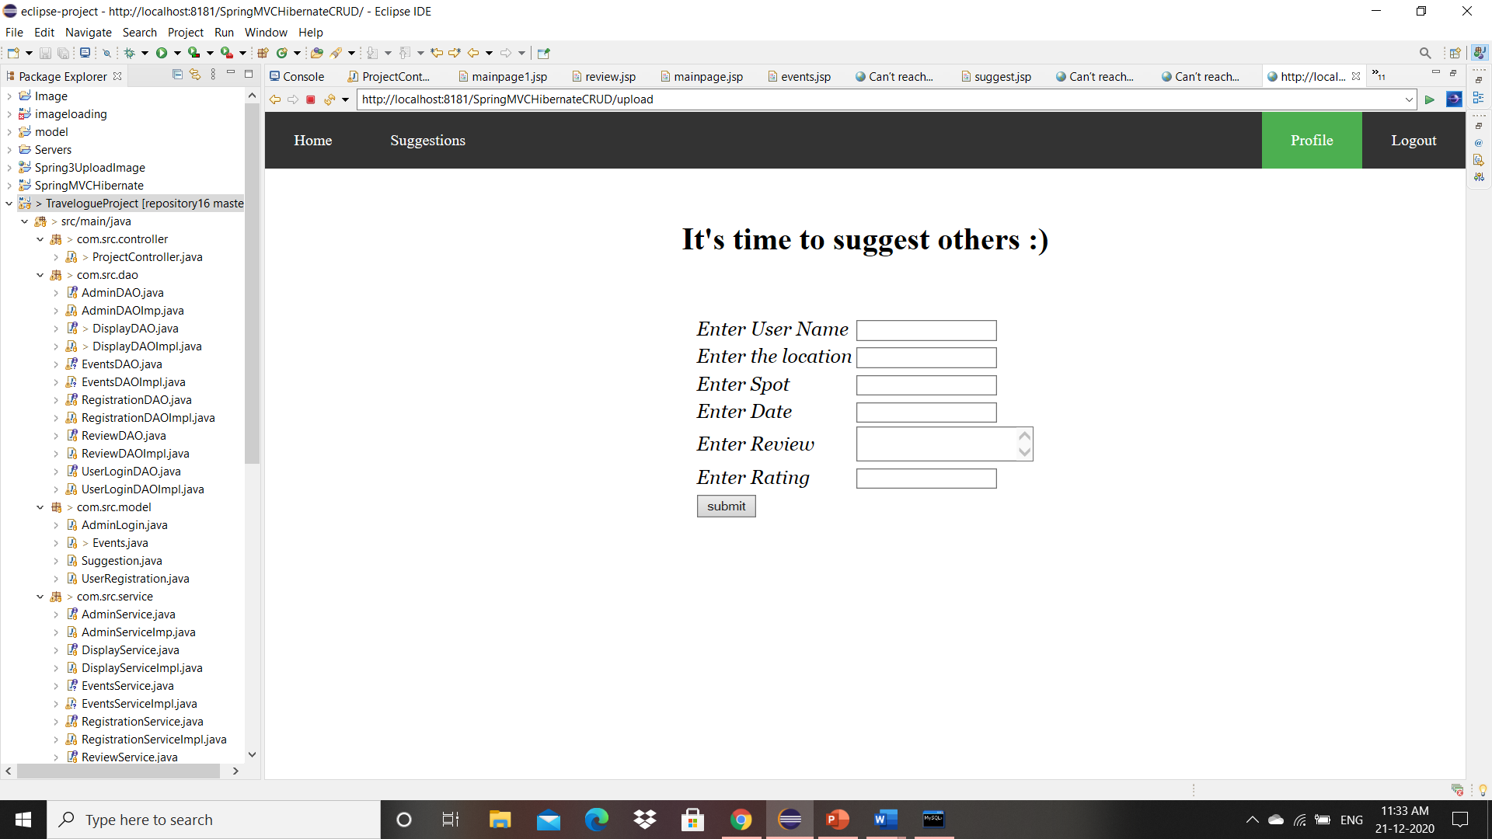

Result: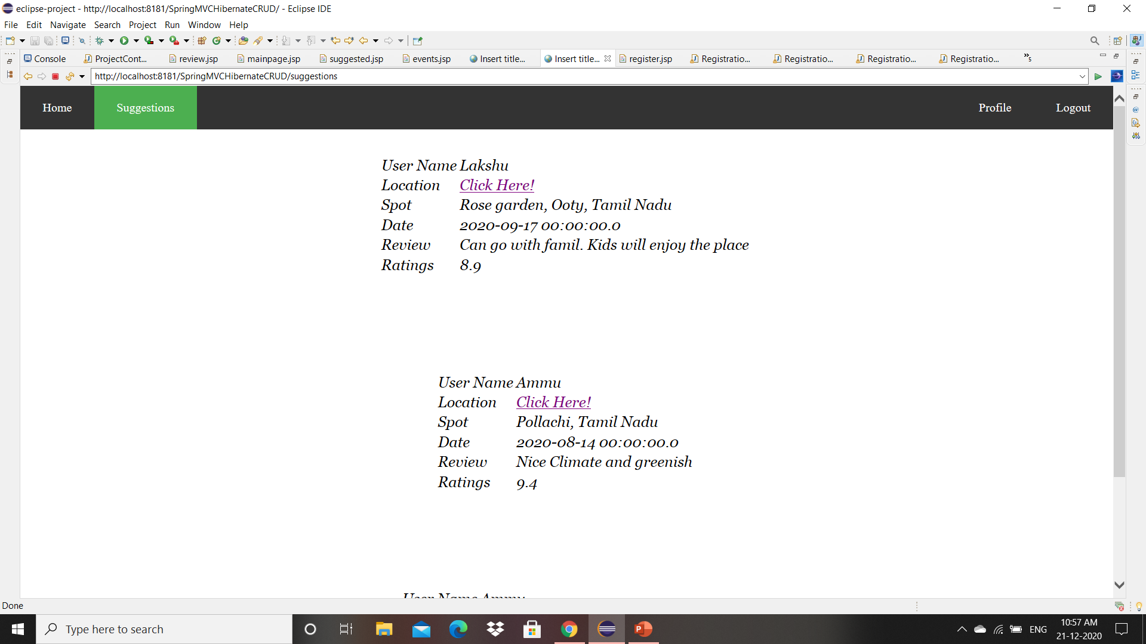

Conclusion and future work:

The proposed project suggests the spots to the user.

The user can take that suggestions with the rating and location also specified.

It can be extended by uploading images and announce more events.